Preface
A style guide is an immensely useful tool to have around when creating a document or a series of documents. It makes it easy to uniformly format all of the documents in a series. It also addresses some of the common issues seen within documents to help authors avoid those mistakes.

This style guide is for the Supplemental Instruction Faculty Guide. However, the styles can be applied to any other document of a similar genre. I based my grammar choices on The Elements of Style by William Strunk Jr. and E.B. White.

Table of Contents
Design 1
Bold and Italics 1
Chart and Table Format 1
Color Use 1
Headings 2
Hyperlinks 3
Lists 3
Page Numbers 4
Paragraphs 4
Table of Contents Format 5
Page Layout Samples 6
Style 9
Grammar 10
Exclamations 10
Parallel Structure 10
Tone 10
Logo and Contact Information Use 11
Contact Information 12

Design
Bold and Italics
Do not bold or italicize items within a document unless a part of a header. If you want to emphasize something within a document, either rephrase the sentence to focus on that item or, if it is large and significant enough, create a new section with a heading following the heading structure.

Chart and Table Format
Location
Put all data charts in an appendix so as to not interrupt the flow of the document. Integrate any tables into the main text, making sure to lead into them in the main text. Do not have tables stand alone on a separate page.

Orientation
In all data charts, horizontally center the titles and numbers inside the columns. Also, vertically center the titles. In all tables, center the text horizontally and vertically.

Color
If printing in grayscale, use grayscale colors.

Punctuation
Do not add end punctuation.

Chart Example
See Page Layout Samples for an example of a chart.

Table Example
See Page Layout Samples for an example of a table.

Color Use
Use maroon, white, and black on the cover page and grayscale everywhere else. For cost-saving purposes, the interior of the document will most likely be printed in grayscale. Therefore, it is important to exclusively use grayscale on the interior pages because color would not print well in grayscale.

Headings
Use the following heading structure. Make sure to use them in order and consistently. A consistent heading structure makes it easier for readers to navigate documents. It is important to apply consistent style doing otherwise because it makes it difficult for readers to follow the document.

Title Heading: Georgia, 48 pt., left-aligned, single-spaced

First-Level Heading: Georgia, 20 pt., left-aligned, ragged right, single-spaced, italics

Second-Level Heading: Georgia, 14 pt., left-aligned, ragged right, single-spaced, bold

Third-Level Heading: Georgia, 12 pt., left-aligned, ragged right, single-spaced, bold, italics

Body Text: Georgia, 11 pt., left-aligned, ragged right, single-spaced

Subtext: Georgia, 8 pt., left-aligned, ragged right, single-spaced

Chart Heading: Georgia, 20 pt., centered, ragged right, single-spaced, italics

Also, add a space after the headings before beginning lists.

Hyperlinks
Manually remove the hyperlinks from all web addresses included in the document. Leaving in the hyperlinks changes the color and format of the text.

Lists
Use the standard bulleted list style and avoid stylized bullets. Stylized bullets are not professional. Also, make sure the formatting is consistent. Do not punctuate list items unless the items include multiple complete sentences:

- Line 1
- Line 2
- Line 3

If you do add punctuation, punctuate all the items in the list consistently:

- Use bulleted lists unless the order of what needs to be listed is important. If numbering is necessary, use the same spacing as the bulleted lists.
- Add six points of space after each item except for the last item to increase readability. Do not single-space the items since this many decrease the readability of the document.
- Do not indent paragraphs or sentences just before, immediately in the middle of, or after bulleted lists. This makes the document more readable. Refer to the Lists and Page Numbers sections for examples.
- Adjust the bullet position 0.25″ from the margin. Make the text indent 0.5″ from the margin.

Page Numbers
In order to create the circular design page numbers, take the following steps:

- Insert page numbers on the right side of the page.
- Make the page number Georgia, 11 pt.
- Make the page number white.
- Send the page number to the front using the order function.
- Insert a small circle. Place it at the right side of the page on top of the page number. Make both the shape fill and outline black text 1.
- Insert a slightly larger circle. Make both the shape fill and outline black text 1, lighter 25%.
- Insert one last circle, slightly larger than the second one. Make both the shape fill and outline white, background 1, darker 50%.
- Add a black line which extends from the bottom of the circles at a 45% angle to the left side of the page.
- Group the circles and the line.
- Make the footer from the bottom 0” and the header from the top 0.5”. Make sure the circles do not get cut off at the bottom when printing.

This design ties into the cover page design and creates a sense of continuity within the document.

Paragraphs
Do not indent the first paragraph under a heading. Add a single space in between paragraphs.

Indent all paragraphs following the first paragraph. This adds additional interest to the document and helps the overall flow. (Notice the format of this page’s paragraphs.)

Table of Contents Format
When creating a table of contents, only apply pre-created headings to the things you want to include. Manually format all other headings. Also, when updating the contents of the table of contents, verify that the font type and size is still correct.
Page Layout Samples
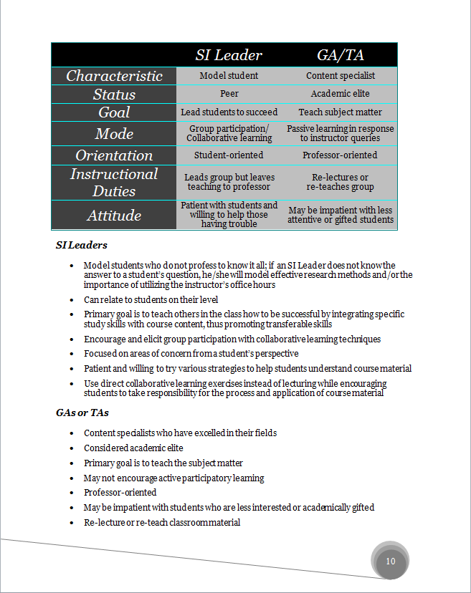
The following three snapshots are samples of the formatting referred to in the Style Guide. Use these as examples of how to format the document:
Table Format
Chart Headers

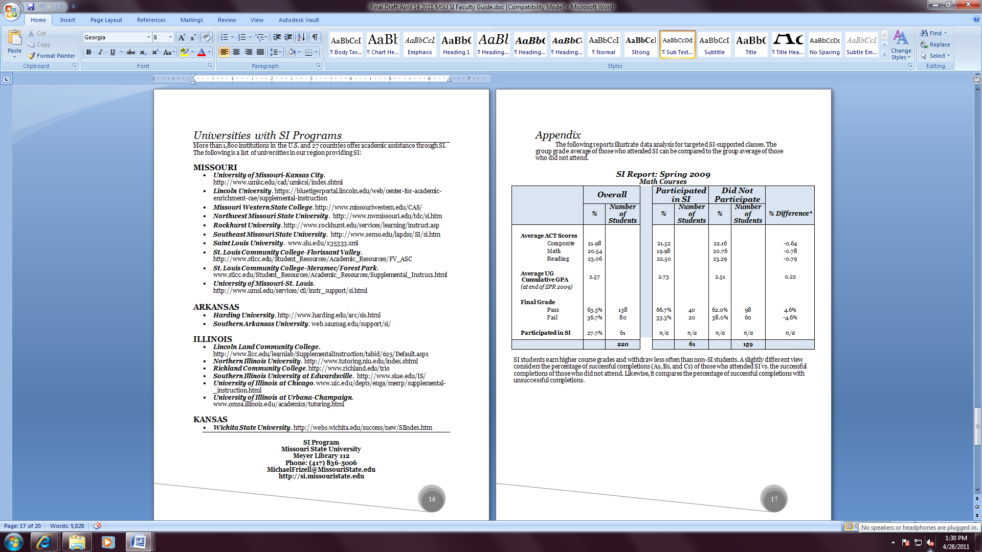
Sample Chart
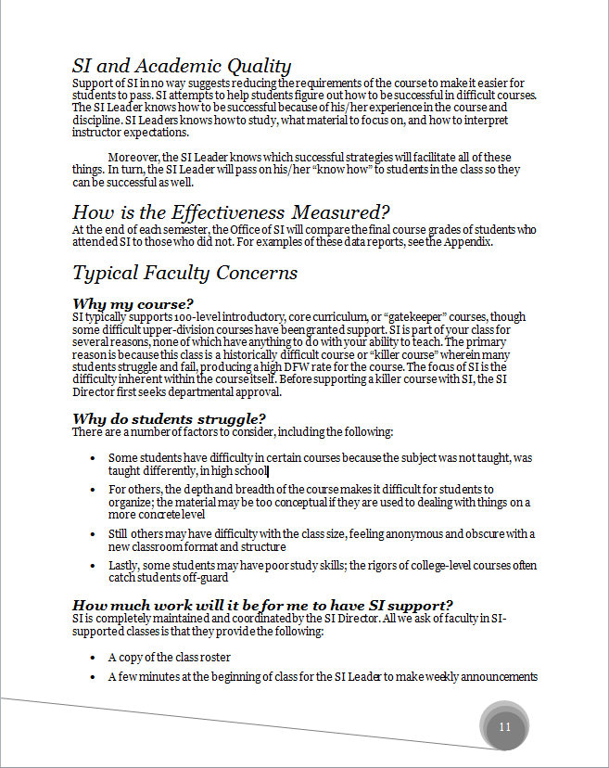
Heading 1
Heading 3
Bulleted Lists
Body Text
Page Number Design
Style
Acronyms/Abbreviations
Write out the word in its first occurrence. Afterwards, use abbreviations. Make sure to be consistent when using abbreviations. To not do so makes it harder for the readers to follow the document. The following are some abbreviations and acronyms included in the document:

- UMKC: University of Missouri-Kansas City
- SI: use SI instead of Supplemental Instruction after the first mention
  - SI Director
  - SI Leaders
  - SI sessions
- GA or TA: use GA or TA after the first mention of Graduate Assistant and Teaching Assistant

The following is an example of how to use abbreviations:

Supplemental Instruction (SI) is the brainchild of Dr. Deanna Martin from the University of Missouri-Kansas City (UMKC). In 1973, Dr. Martin developed the SI Model in response to her university’s concern regarding the high failure rate among minorities in medical school. Initial SI evaluation results were so impressive, the program quickly spread to UMKC’s health and professional schools and, soon after that, throughout the entire university.
Grammar
Exclamations
Do not include exclamatory sentences. In particular, do not include exclamatory sentences when describing what SI Leaders cannot do or are not expected to do as it creates a negative impression on readers and comes across as hostile.

Parallel Structure
When listing items in a sentence, make sure the listed items are all parallel. The following is an example of good parallel structure:

After class, make sure to take out the trash, finish your homework, and clean your room.

Tone
Make sure to keep a friendly but professional tone throughout the document. Avoid sounding negative or overly informal, especially when describing the limitations and restrictions of the program and SI Leader duties.

The following, taken from the Supplemental Instruction Faculty Guide, is a good example of a proper tone:

SI Leaders typically do not answer questions you ask the class. The SI Leader is there to get a better sense of the areas emphasized during lectures so that he or she can develop more focused SI sessions.

This example demonstrates how the author can express the limitations of the program without appearing negative.
Logo and Contact Information Use
Placement
Use the MSU logo only on the cover page.

Size


Inclusion of Contact Information
Include the following at the beginning of the document after the Table of Contents and at the very end just before the Appendix:

SI Program
Missouri State University
Meyer Library 112
Phone: (417) 836-5006
MichaelFrizell@MissouriState.edu
http://si.missouristate.edu
Also, include the phone number, e-mail address, and web address at appropriate places within the document.
Contact Information
The document’s author can be contacted for any more information:

Mr. Michael Frizell
Director, Writing Center
Missouri State University
901 S. National Avenue
Springfield, MO 65897

MichaelFrizell@MissouriState.edu
(417) 836-5006

